Element Crossword

♦ Write the name of each element next to its symbol. You may need to use your periodic table.

♦ Fit the name of each element into the clueless crossword on the right. Some have been filled in to get you started.

|  |  |  |  |
| --- | --- | --- | --- |
| **Symbol** | **Element** | **Symbol** | **Element** |
| Sn | **Tin** | Li | **Lithium** |
| Au | **Gold** | Hg | **Mercury** |
| Fe | **Iron** | Si | **Silicon** |
| Pb | **Lead** | U | **Uranium** |
| Zn | **Zinc** | At | **Astatine** |
| Ar | **Argon** | Cl | **Chlorine** |
| B | **Boron** | Cr | **Chromium** |
| Ba | **Barium** | F | **Fluorine** |
| C | **Carbon** | H | **Hydrogen** |
| Cu | **Copper** | N | **Nitrogen** |
| He | **Helium** | Pt | **Platinum** |
| I | **Iodine** | Se | **Selenium** |
| Ni | **Nickel** | Al | **Aluminium** |
| O | **Oxygen** | Ge | **Germanium** |
| Ra | **Radium** | Mg | **Magnesium** |
| Ag | **Silver** | Mn | **Manganese** |
| Na | **Sodium** | K | **Potassium** |
| S | **Sulfur** | Sr | **Strontium** |
| As | **Arsenic** | P | **Phosphorous** |
| Br | **Bromine** | Es | **Einsteinium** |
| Ca | **Calcium** | Mo | **Molybdenum** |

|  |  |  |  |  |  |  |  |  |  |  |  |  |  |  |  |  |  |  |  |  |  |  |  |  |  |  |
| --- | --- | --- | --- | --- | --- | --- | --- | --- | --- | --- | --- | --- | --- | --- | --- | --- | --- | --- | --- | --- | --- | --- | --- | --- | --- | --- |
|  |  |  |  |  |  |  |  |  |  |  |  |  |  |  |  |  |  |  |  |  |  |  |  |  |  |  |
|  |  |  |  |  |  |  |  |  |  |  |  |  |  |  |  |  |  |  |  |  |  |  | B |  |  |  |
|  |  |  |  |  |  |  |  |  | M | E | R | C | U | R | Y |  |  |  |  |  | P |  | A |  |  |  |
|  |  |  |  |  |  |  |  |  |  |  |  | A |  |  |  |  |  |  |  |  | L |  | R |  |  |  |
|  |  |  |  | C |  |  |  |  |  |  |  | L |  |  |  |  | G | E | R | M | A | N | I | U | M |  |
|  |  |  |  | O |  | I |  | S | I | L | I | C | O | N |  | G |  |  |  |  | T |  | U |  |  |  |
|  |  |  |  | P |  | R |  |  |  |  |  | I |  |  | P | O | T | A | S | S | I | U | M |  |  |  |
|  |  |  |  | P | H | O | S | P | H | O | R | U | S |  |  | L |  | L |  |  | N |  |  |  |  |  |
|  |  |  |  | E |  | N |  |  | Y |  |  | M |  | S | O | D | I | U | M |  | U |  |  |  |  |  |
|  |  |  |  | R |  |  |  |  | D |  |  |  |  | U |  |  |  | M |  |  | M |  |  |  |  |  |
|  |  |  |  |  | F | L | U | O | R | I | N | E |  | L | I | T | H | I | U | M |  |  |  |  |  |  |
|  |  |  |  |  |  |  |  |  | O |  |  |  |  | F |  |  |  | N |  |  |  |  |  |  |  |  |
|  |  |  |  |  |  |  | M | A | G | N | E | S | I | U | M |  |  | I |  |  |  |  |  |  |  |  |
|  |  |  |  |  |  |  | O |  | E |  |  |  |  | R | A |  |  | U |  |  |  |  |  |  |  |  |
|  |  |  |  |  | S | E | L | E | N | I | U | M |  |  | N |  |  | M |  |  |  |  |  |  |  |  |
|  |  |  |  |  | U |  | Y |  |  |  | R |  | A | R | G | O | N |  |  |  |  |  |  |  |  |  |
|  |  |  |  |  | L |  | B |  | L | E | A | D |  |  | A |  |  |  |  |  |  |  |  |  |  |  |
|  |  |  |  |  | V |  | D |  |  |  | N |  | A |  | N |  |  | N |  |  |  |  |  |  |  |  |
|  |  |  |  |  | E |  | E |  |  | E | I | N | S | T | E | I | N | I | U | M |  |  |  |  |  |  |
|  | C | H | L | O | R | I | N | E |  |  | U |  | T |  | S |  |  | T |  |  |  |  |  |  |  |  |
|  |  |  |  | X |  |  | U |  | C |  | M |  | A |  | E |  |  | R |  | I |  |  |  |  |  |  |
|  |  |  |  | Y |  |  | M |  | A |  |  |  | T |  |  |  | B | O | R | O | N |  |  |  |  |  |
|  |  |  |  | G |  |  |  | A | R | S | E | N | I | C |  |  |  | G |  | D |  |  |  |  |  |  |
|  |  |  |  | E |  |  |  |  | B |  |  |  | N |  | S |  | H | E | L | I | U | M |  |  |  |  |
|  |  | Z | I | N | C |  | B | R | O | M | I | N | E |  | T |  |  | N |  | N |  |  |  |  |  |  |
|  |  |  |  |  |  |  |  |  | N |  |  | I |  |  | R |  |  |  |  | E |  |  |  |  |  |  |
|  |  |  |  |  |  |  |  |  |  |  |  | C | H | R | O | M | I | U | M |  |  |  |  |  |  |  |
|  |  |  |  |  |  |  |  |  |  |  |  | K |  |  | N |  |  |  |  |  |  |  |  |  |  |  |
|  |  |  |  |  |  |  |  |  |  |  |  | E |  |  | T |  |  |  |  |  |  |  |  |  |  |  |
|  |  |  |  |  |  |  |  |  |  |  |  | L |  | T | I | N |  |  |  |  |  |  |  |  |  |  |
|  |  |  |  |  |  |  |  |  |  |  |  |  |  |  | U |  |  |  |  |  |  |  |  |  |  |  |
|  |  |  |  |  |  |  |  |  |  |  |  |  |  |  | M |  |  |  |  |  |  |  |  |  |  |  |
|  |  |  |  |  |  |  |  |  |  |  |  |  |  |  |  |  |  |  |  |  |  |  |  |  |  |  |

Periodic Table Puzzles

Rearrange the symbols for the elements and use the clues to figure out the words.

Example: **Something to follow** (Thorium + Protactinium)

Th + Pa = Path

**You want to finish first** (Cerium + Radium)

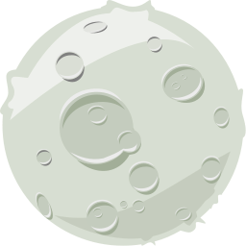**Ce + Ra = Race**

**Think of the moon** (Argon + Nitrogen + Lutetium)

**Ar + N + Lu = Lunar**

**Holiday home in the woods** (Calcium + Indium + Boron)

**Ca + In + B = Cabin**

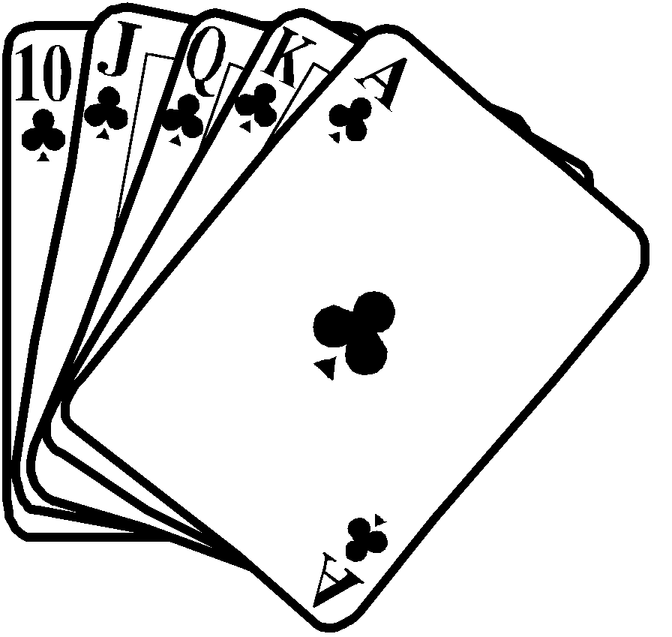

**Card game** (Erbium + Polonium + Potassium)

**Er + Po + K = Poker**

**A small angle** (Uranium + Actinium + Tellurium)

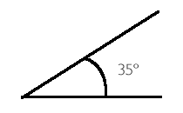**U + Ac + Te = Acute**

**Sandy** (Actinium + Beryllium + Hydrogen)

**Ac + Be + H = Beach**

**Water vapour** (Americium + Sulphur + Tellurium)

**Am + S + Te = Steam**

**Somewhere** (Cerium + Lanthanum + Phosphorus)

**Ce + La + P = Place**

**Unit of time** (Cobalt + Neodymium + Selenium)

**Co + Nd + Se = Second**

**Something you would like a lot of** (Neon + Yttrium + Molybdenum)

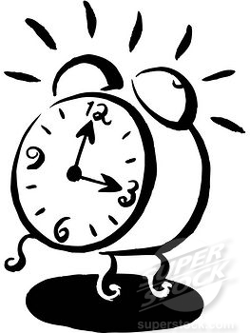**Ne + Y + Mo = Money**

**Beware of this snake** (Oxygen + Carbon + Boron + Radium)

**O + C + B + Ra = Cobra**

**A brother’s son** (Tungsten + Phosphorus + Neon + Helium)

**W + P + Ne + He = Nephew**

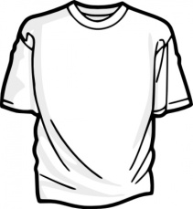**Shirt and pants** (Oxygen + Einsteinium + Chlorine + Thorium)

**O + Es + Cl + Th = Clothes**

**Dracula’s bed** (Indium + Carbon + Fluorine + Oxygen + Fluorine)

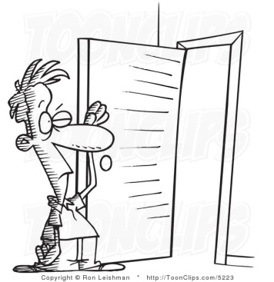**In + C + F + O + F = Coffin**

**Not anybody** (Oxygen + Boron + Dysprosium + Nitrogen + Oxygen)

**O + B + Dy + N + O = Nobody**

**Do this to a door** (Nitrogen + Carbon + Potassium + Oxygen + Potassium)

**N + C + K + O + K = Knock**

**Try to find the end of this** (Tungsten + Radium + Boron + Indium + Oxygen)

**W + Ra + B + In + O = Rainbow**

**Think Hawaii and Tasmania** (Lanthanum + Iodine + Darmstadtium + Nitrogen + Sulphur)

**La + I + Ds + N + S = Islands**

**They can make you laugh** (Oxygen + Chlorine + Tungsten + Sulphur + Nitrogen)

**O + Cl + W + S + N = Clowns**

**A favourite food** (Holmium + Cobalt + Tellurium + Carbon + Lanthanum)

**Ho + Co + Te + C + La = Chocolate**

**Large horned mammal** (Erbium + Oxygen + Rhodium + Osmium + Carbon + Indium + Sulfur)

**Er + O + Rh + Os + C + In + S = Rhinoceros**

**Now have a go at creating your own words and clues.**

*The Chemical Kid*

The Chemical Kid mounted his trusty horse, Old (Au) **gold**. He strapped his shooting (Fe) **iron** to his side and headed out from the bright (Ne) **neon** lights. He was determined to rob the stagecoach of its precious (U) **uranium** load. He inhaled a deep breath of (O) **oxygen** and coughed on the (S) sulphur from the nearby factories. It was really hot and the (Hg) **mercury** was rising. He took a drink of (H2O) **water** and spat as he tasted the (Cl) **chlorine**. He rode north, his bones aching from the (Ca) **calcium** deposits built up from years of riding the old (Zn) **zinc** trail. Overhead he saw a (He) **helium** balloon in the sky and knew that the stage coach was approaching. It was guarded by an old sheriff with a (Sn) **tin** badge. “Stop,” the kid yelled, “or I’ll fill you full of (Pb) **lead**.” The sheriff went for his gun but was too slow. The kid’s gun blazed like flaming (Mg) **magnesium** and the (Cu) **copper** fell to the ground. Anyone who drew on the kid should have known his life wasn’t worth a (Ni) **nickel**. A pretty (Pt) **platinum** blond on the stagecoach screamed as the kid pulled out some (N) **nitrogen** compounds to blow the strongbox. Suddenly a shout rang out. “Hi, Ho, (Ag) **silver**.” A masked man on a white horse raced across the (Si) **silicon** sands. The kid was captured and put behind cold (Fe) **iron** bars.

**Challenge**

Use the word CHEMISTRY to make as many chemical symbols as you can.

**C – Carbon**

**H – Hydrogen**

**I – Iodine**

**Cr - Chromium**

**Y – Yttrium**

**S - Sulfur**

**He – Helium**

**Ce – Cenum**

**Cs – Caesium**

**Hs – Hassium**

**Er – Erbium**

**Es – Einsteinium**

**Mt – Meitnerium**

**Ir – Iridium**

**Si – Silicon**

**Sc – Scandium**

**Se – Selenium**

**Sr – Strontium**

**Sm – Samarium**

**Ti – Titanium**

**Tc – Technetium**

**Te – Tellurium**

**Tm – Thulium**

**Th – Thorium**

**Rh – Rhodium**

**Re – Rhenium**

Element Word Sleuth

|  |  |  |  |  |  |  |  |  |  |  |  |  |  |  |  |  |  |  |  |  |  |  |  |  |  |  |  |
| --- | --- | --- | --- | --- | --- | --- | --- | --- | --- | --- | --- | --- | --- | --- | --- | --- | --- | --- | --- | --- | --- | --- | --- | --- | --- | --- | --- |
| **M** | **Y** | **L** | **O** | **C** | **G** | **F** | **C** | **O** | **P** | **P** | **E** | **R** | **M** | **U** | **I** | **M** | **O** | **R** | **H** | **C** | **M** | **D** | **N** | **M** | **P** | **M** | **Y** |
| **B** | **N** | **R** | **U** | **S** | **I** | **E** | **T** | **Y** | **R** | **L** | **M** | **U** | **I** | **N** | **F** | **A** | **H** | **U** | **V** | **M** | **L** | **U** | **U** | **O** | **U** | **I** | **T** |
| **I** | **O** | **P** | **E** | **B** | **M** | **N** | **R** | **O** | **T** | **A** | **K** | **R** | **Y** | **P** | **T** | **O** | **N** | **T** | **D** | **O** | **U** | **I** | **I** | **I** | **D** | **L** | **T** |
| **G** | **M** | **R** | **L** | **V** | **P** | **I** | **M** | **M** | **F** | **T** | **M** | **U** | **I** | **M** | **D** | **A** | **C** | **H** | **G** | **S** | **M** | **I** | **H** | **R** | **A** | **A** | **E** |
| **E** | **I** | **Y** | **O** | **U** | **L** | **E** | **U** | **L** | **A** | **I** | **R** | **T** | **B** | **I** | **L** | **S** | **M** | **E** | **L** | **R** | **A** | **T** | **B** | **B** | **A** | **U** | **R** |
| **S** | **T** | **R** | **O** | **N** | **T** | **I** | **U** | **M** | **D** | **N** | **H** | **I** | **U** | **X** | **G** | **U** | **P** | **R** | **E** | **E** | **I** | **M** | **O** | **R** | **M** | **B** | **B** |
| **E** | **N** | **C** | **P** | **H** | **L** | **O** | **S** | **U** | **E** | **U** | **I** | **M** | **U** | **I** | **N** | **R** | **O** | **F** | **I** | **L** | **A** | **C** | **A** | **U** | **E** | **M** | **I** |
| **N** | **A** | **M** | **I** | **D** | **R** | **U** | **N** | **P** | **L** | **M** | **V** | **U** | **L** | **M** | **A** | **O** | **L** | **O** | **T** | **C** | **K** | **D** | **I** | **R** | **U** | **T** | **U** |
| **A** | **R** | **U** | **U** | **I** | **M** | **O** | **T** | **I** | **N** | **P** | **B** | **I** | **M** | **S** | **R** | **H** | **O** | **R** | **S** | **B** | **H** | **M** | **Y** | **I** | **I** | **Y** | **M** |
| **G** | **M** | **E** | **N** | **I** | **G** | **U** | **U** | **E** | **U** | **I** | **R** | **R** | **E** | **L** | **S** | **P** | **N** | **D** | **T** | **E** | **L** | **L** | **N** | **S** | **M** | **U** | **H** |
| **N** | **U** | **E** | **N** | **R** | **N** | **M** | **I** | **M** | **T** | **M** | **S** | **O** | **P** | **W** | **E** | **S** | **I** | **I** | **R** | **O** | **L** | **H** | **O** | **G** | **D** | **E** | **M** |
| **A** | **I** | **M** | **A** | **I** | **B** | **A** | **U** | **N** | **G** | **I** | **D** | **H** | **T** | **L** | **N** | **O** | **U** | **U** | **H** | **I** | **A** | **E** | **A** | **R** | **L** | **T** | **N** |
| **M** | **R** | **D** | **U** | **X** | **T** | **L** | **T** | **W** | **O** | **Y** | **U** | **T** | **M** | **A** | **I** | **H** | **M** | **M** | **U** | **H** | **O** | **D** | **N** | **I** | **I** | **E** | **O** |
| **S** | **U** | **M** | **G** | **I** | **A** | **A** | **E** | **I** | **M** | **C** | **Z** | **M** | **O** | **M** | **C** | **P** | **R** | **M** | **S** | **N** | **O** | **D** | **U** | **I** | **R** | **N** | **B** |
| **C** | **L** | **I** | **E** | **T** | **S** | **M** | **T** | **I** | **T** | **M** | **R** | **G** | **U** | **D** | **Y** | **T** | **N** | **R** | **V** | **L** | **W** | **M** | **I** | **B** | **U** | **I** | **E** |
| **A** | **L** | **M** | **N** | **D** | **B** | **O** | **U** | **S** | **N** | **V** | **U** | **I** | **M** | **N** | **O** | **C** | **I** | **L** | **I** | **S** | **G** | **X** | **I** | **N** | **N** | **M** | **L** |
| **N** | **E** | **A** | **S** | **A** | **L** | **M** | **R** | **I** | **A** | **S** | **D** | **I** | **Z** | **T** | **E** | **C** | **H** | **N** | **E** | **T** | **I** | **U** | **M** | **D** | **E** | **O** | **I** |
| **D** | **T** | **G** | **W** | **B** | **R** | **M** | **H** | **P** | **D** | **O** | **T** | **O** | **N** | **I** | **M** | **Y** | **I** | **N** | **I** | **M** | **M** | **U** | **I** | **N** | **C** | **R** | **U** |
| **I** | **M** | **N** | **U** | **R** | **N** | **U** | **M** | **T** | **S** | **I** | **X** | **E** | **R** | **I** | **D** | **U** | **O** | **N** | **E** | **U** | **I** | **U** | **D** | **U** | **M** | **B** | **M** |
| **U** | **B** | **E** | **D** | **L** | **E** | **I** | **C** | **A** | **U** | **Y** | **B** | **I** | **I** | **R** | **M** | **B** | **I** | **R** | **P** | **S** | **M** | **E** | **N** | **U** | **M** | **R** | **T** |
| **M** | **E** | **S** | **F** | **E** | **O** | **N** | **M** | **N** | **G** | **M** | **D** | **U** | **O** | **N** | **R** | **U** | **C** | **L** | **E** | **O** | **L** | **D** | **I** | **U** | **P** | **U** | **R** |
| **G** | **R** | **I** | **R** | **K** | **N** | **E** | **C** | **E** | **I** | **I** | **S** | **G** | **R** | **A** | **I** | **U** | **L** | **A** | **L** | **E** | **T** | **M** | **N** | **N** | **N** | **H** | **H** |
| **A** | **K** | **U** | **A** | **C** | **R** | **H** | **N** | **I** | **U** | **Z** | **E** | **I** | **C** | **P** | **R** | **U** | **C** | **A** | **E** | **A** | **Y** | **A** | **I** | **G** | **N** | **P** | **E** |
| **L** | **E** | **M** | **N** | **I** | **D** | **T** | **S** | **M** | **U** | **N** | **E** | **D** | **B** | **Y** | **L** | **O** | **M** | **V** | **X** | **D** | **H** | **O** | **S** | **O** | **T** | **L** | **N** |
| **L** | **L** | **B** | **C** | **N** | **C** | **U** | **R** | **I** | **U** | **M** | **N** | **E** | **G** | **O** | **R** | **T** | **I** | **N** | **O** | **T** | **B** | **T** | **R** | **S** | **P** | **U** | **I** |
| **I** | **I** | **I** | **I** | **E** | **U** | **R** | **O** | **P** | **I** | **U** | **M** | **R** | **A** | **D** | **I** | **U** | **M** | **E** | **N** | **I** | **E** | **I** | **U** | **V** | **I** | **S** | **U** |
| **U** | **U** | **M** | **U** | **I** | **N** | **I** | **T** | **C** | **A** | **N** | **O** | **N** | **E** | **X** | **M** | **I** | **N** | **A** | **U** | **N** | **C** | **A** | **L** | **C** | **I** | **U** | **M** |
| **M** | **M** | **T** | **M** | **U** | **I** | **R** | **E** | **C** | **M** | **U** | **I** | **D** | **A** | **N** | **A** | **V** | **L** | **M** | **P** | **A** | **L** | **L** | **A** | **D** | **I** | **U** | **M** |

Actinium

Aluminium

Americium

Antimony

Argon

Arsenic

Astatine

Barium

Berkelium

Beryllium

Bismuth

Boron

Bromine

Cadmium

Caesium

Calcium

Californium

Carbon

Cerium

Chlorine

Chromium

Cobalt

Copper

Curium

Dysprosium

Einsteinium

Erbium

Europium

Fermium

Fluorine

Francium

Gadolinium

Gallium

Germanium

Gold

Hafnium

Hahnium

Helium

Holmium

Hydrogen

Indium

Iodine

Iridium

Iron

Krypton

Lanthanum

Lawrencium

Lead

Lithium

Lutetium

Magnesium

Manganese

Mendeleevium

Mercury

Molybdenum

Neodymium

Neon

Neptunium

Nickel

Niobium

Nitrogen

Nobelium

Osmium

Oxygen

Palladium

Phosphorus

Platinum

Plutonium

Polonium

Potassium

Praseodymium

Promethium

Protactinium

Radium

Radon

Rhenium

Rhodium

Rubidium

Ruthenium

Rutherfordium

Samarium

Scandium

Selenium

Silicon

Silver

Sodium

Strontium

Sulphur

Tantalum

Technetium

Tellurium

Terbium

Thallium

Thorium

Thulium

Tin

Titanium

Tungsten

Uranium

Vanadium

Xenon

Ytterbium

Yttrium

Zinc

Zirconium